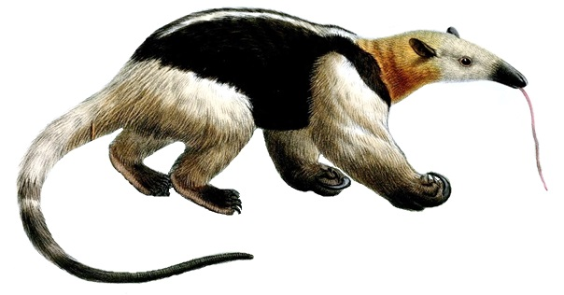

Design Research

Directions: Fill out the chart as you view the video of the Southern tamandua.

 | Adaptation  feature/part of the body | Function  How does it help the Southern tamandua survive?
1
2
3
4
5
6
7

Household Tool Design Analysis

Tool #1 Description:
How does this tool help you in your everyday life?
What about this design works well?
What about this design does not work well?
What constraints must be considered if you redesigned this tool?
Is this a sustainable tool design? Why or why not?

Tool #2 Description:
How does this tool help you in your everyday life?
What about this design works well?
What about this design does not work well?
What constraints must be considered if you redesigned this tool?
Is this a sustainable tool design? Why or why not?

Design Planning

- What Southern tamandua adaptation will help inspire a new and improved design for one of the tools you analyzed?
Adaptation | Function

- Sketch your design idea below
Southern Tamandua Biomimicry Design Idea

Design Overview

- How does your design work? Explain.

- How did the Southern tamandua inspire your design?

- Fill out the table below as it relates to your biomimicry-inspired design.

New and Improved Tool Description:
How does this tool help you in your everyday life?
What about this design works well?
What about this design does not work well?
What constraints must be considered if you redesigned this tool?
Is this a sustainable tool design? Why or why not?

- How do the risks and benefits of your improved design compare with the original?

- How was your design impacted through both considering the the constraints of the original design as well as the biomimicry design goal of sustainability?

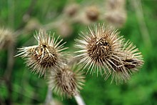
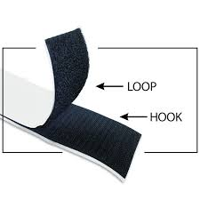
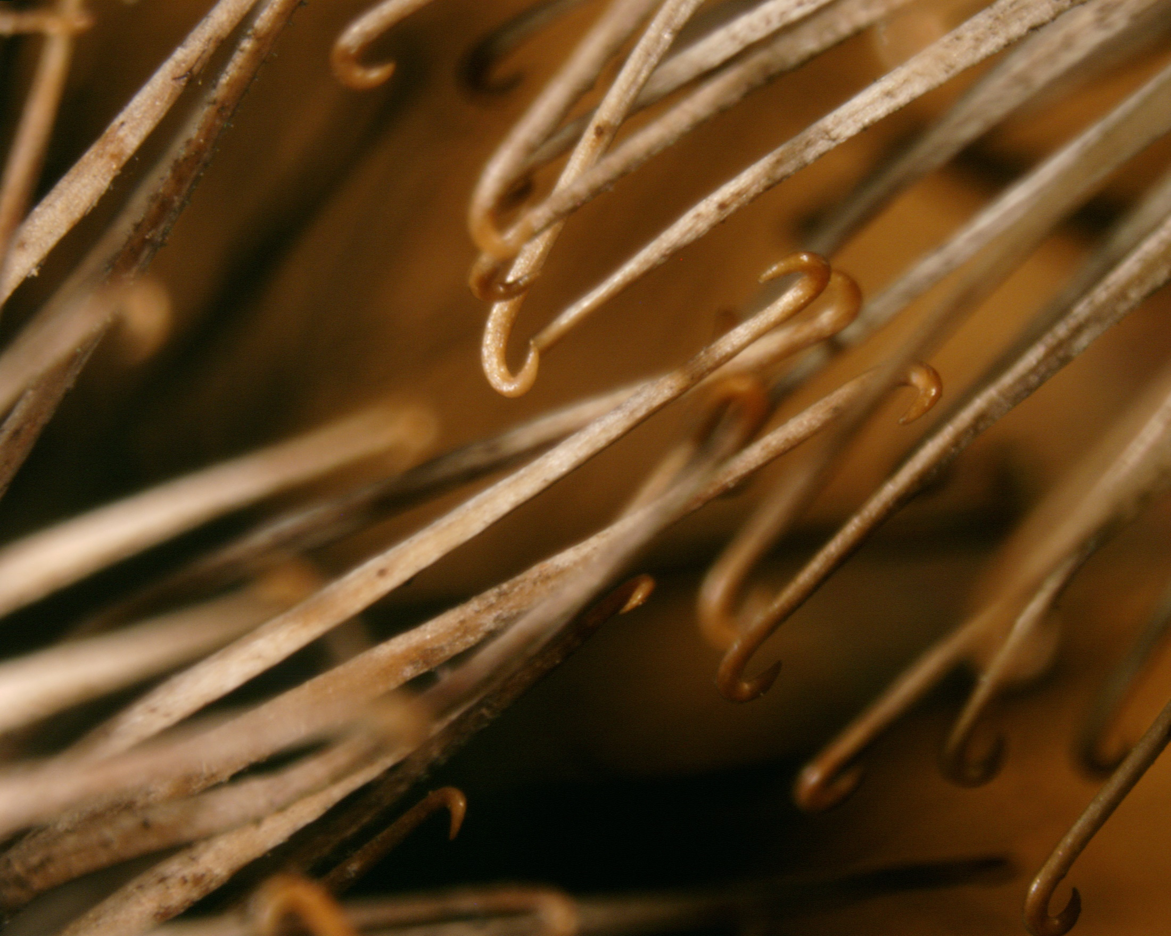
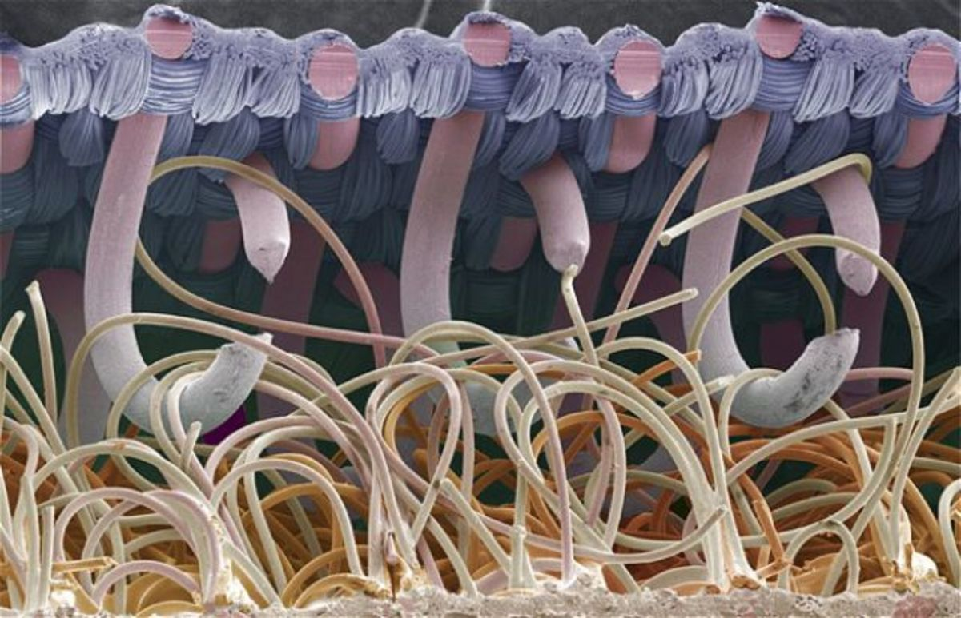
BURS – ZOOMED IN
VELCRO – ZOOMED IN

