Engineering FOR Animals Activity Resource

What is Enrichment?

Directions: Watch Minnesota Zoo Video: Animal Enrichment. Take notes on the following questions and be ready to discuss them with your classmates or submit them to your teacher.

- What did you observe?

- What behaviors did you see each animal display? How did each animal’s behavior change once it interacted with the object?

- Why were the objects different for each animal? Why do you think these items were given to each animal?

- If we were to swap the objects for different animals, how do you think that would change the behavior we observed?

- What might prevent us from swapping the Fennec fox’s enrichment with the tiger?

The items that you saw the animals interacting with are called enrichments. Enrichment is anything that is provided to help improve the well-being of an animal by providing choices, mental challenges, or specific activities.

Customizing Enrichment for Different Animals

Directions: Read the following text that explains what enrichment is and how zoos use it. This will help you to develop your own enrichment plan for your pet.

How do Zoos Provide Enrichment to Animals?
Exhibit  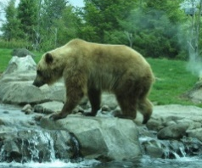 | Habitat design is an important consideration for providing enrichment. Including things such as different levels for the animal to walk on, items to climb and places to hide are all ideas used to keep an animal interested in its environment. Often ropes, nesting/denning areas, feed/water dispensers, and crevices/crannies for food hiding are also considerations that can be made when planning an exhibit. The exhibit space can also be changed to that there is always something new for the animal to see and explore.
Dietary  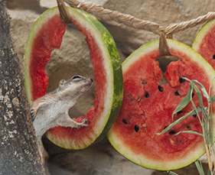 | Food can be presented in a variety of ways to encourage feeding, hunting, foraging behaviors, problem-solving strategies, and to support training by the zookeepers. Food may be fresh, frozen, soft, hard, smooth, rough, heavy, light, cold, or and may be incorporated into puzzle boxes, hung in a tree, hidden in or scattered about the habitat, or even lightly buried in the ground of the exhibit
Novelty  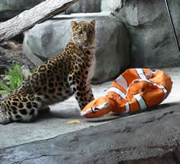 | Unique items can be added to an animal’s enclosure to encourage it to explore and interact with new things. Novel objects are typically specialized by species and play crucial roles in their survival in captivity. Man-made manipulable may include items such as balls, chew toys, PVC pipes, tires, and papier-mâché piñatas filled with treats. Natural enrichment objects can include materials of different textures such as straw, branches, burlap, wool, flowers or wood
Scent 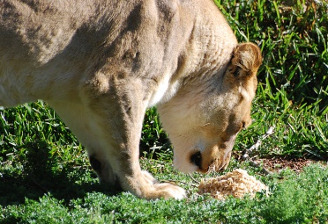 | Zookeepers are always trying to gain species-specific responses, territorial, reproductive, or hunting behaviors in captivity. Using the scent of the animal’s own species, natural prey and predators, or even novel scents such as spices, colognes, or perfumes may help bring about instinctive behaviors
Sound  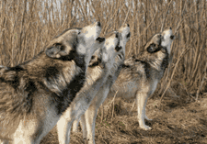 | Recorded sounds can be used to stimulate what animals may hear in their natural environment. Sounds such as animal vocalizations from predators or prey in their natural environment may help animals respond as they would in the wild. The sound of rainfall, seagulls along a coast, or even crickets in a prairie can all be ways zookeepers make their captive homes feel like home
Training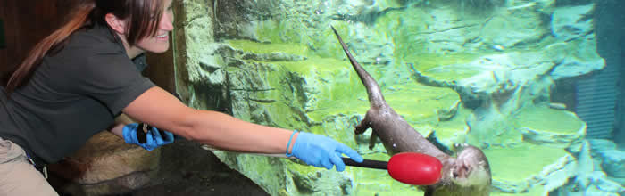 | Keepers train with the animals using positive reinforcement such as offering a food item, usually paired with a training wand, noise, or gesture. Training the animals reduces stress during animal care, encourages relationships between the animal and keeper, and allows humans to better collect data about the animal’s behaviors in captivity.
Social  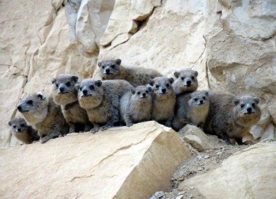 | Many animals at the zoo rely on members of their same species for protection, learning important skills like hunting or even just to play. Living with other animals gives allows animals the chance to interact with one another and because of this they are often are much healthier and happier animals.

SPIDER Enrichment Process

Directions: Read the following text that explains how zoos plan enrichment.
- Finding the perfect enrichments for all zoo animals is a tough job. Because animals are unable to verbally communicate whether they like the enrichment or not, we must watch their behavior and collect data to see how it changes their activity levels.
- To help each one of Minnesota Zoo’s animals get the enrichment care they need, zookeepers and an enrichment specialist work together to set goals and enrichment plans that lead to developing new enrichments to try with the animals. Often times they must come up with a unique and new enrichment design in order to encourage or discourage specific behaviors.
- When looking to choose the perfect enrichment to meet a behavior goal for an animal, enrichment coordinators use the SPIDER process. They must research the animal’s natural behaviors, plan how an enrichment might look and be used, design and build the enrichment, and test the enrichment in order to evaluate its success through collecting behavior and observation data. Once the success of the enrichment is determined, the enrichment may be modified to improve its success or be completely redesigned.
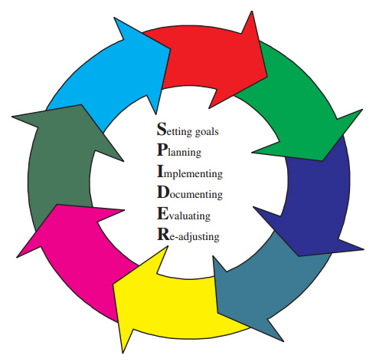

Pet Behavior Observations

Summary of your Pet’s Profile
Directions: First, select a pet to observe. If you don’t have a pet in your home, identify an animal that you see outside frequently that you can study and design enrichment for (bird, rabbit, squirrel, ants). If this is not possible, your teacher may be able to provide you with a video or live stream of an animal to observe.

- What is the name of your pet?

- What type of animal is it?

- What are the behaviors that are common with this type of animal?

- Describe your pet’s personality.

- What are your pet’s likes and dislikes?

- Are there any considerations that need to be made with your pet when using enrichment? (injury, fearful or anxious nature, health issues)

PRE-Enrichment Behavior Observation
Examples of Behaviors
- Resting: sleeping, relaxing, sitting, lying down
- Active: interacting with objects, digging, sniffing, alert & observing surroundings, shaking, self-grooming
- Locomotion: moving to a different space by climbing, running, walking, jumping
- Feeding: foraging, picking up food, eating, drinking
- Social: interacting with another animal including playing, chasing, touching, grooming, biting, hitting, vocalizing
- Other: Any behavior observed not already categorized

To get a better sense of how the pet spends its time without enrichment, you will gather behavior data, or an activity budget, for your pet to give insight as to what might be a good behavior goal to set. Ensure that there are minimal enrichment opportunities by removing any toys, treats, or fun distractions like a family member walking into the room during this time.

Observe your pet for 10 minutes and mark what behavior your pet is displaying at every 30-second interval in the table below. When your observation is complete, calculate what percent of the time was spent on each behavior. Summarize your results on your Pet Enrichment Plan sheet.

 | Resting | Active | Locomotion | Feeding | Social | Other
:30
1:00
1:30
2:00
2:30
3:00
3:30
4:00
4:30
5:00
5:30
6:00
6:30
7:00
7:30
8:00
8:30
9:00
9:30
10:00
Total
Activity Budget % (Total X 5)

Pet Observation Results
Directions: Summarize your results from the Pet Enrichment Behavior Observation by answering the questions below.

- What behaviors occurred most often? Least often?

- Do these results surprise you? Why or why not?

Planning your Pet Enrichment

SPIDER – Setting Goals
Directions: Review the results of your Pet Enrichment Behavior Observation. Choose a behavior based on the data you collected that you would like to encourage or discourage with use of a new enrichment. Ex: If your pet was resting for 80% of your observation, a good enrichment goal might be to encourage them to be more active.

- Enrichment Goal: _______________________________________________

- Describe how your data helped to drive your decision to set this goal.

- Explain how an enrichment can help to reach your goal.

SPIDER – Planning and Design
Directions: Identify potential household and craft materials that you might use to build an enrichment to meet the behavior goal for your pet. Begin planning your design. Use the following questions to guide you.

- Sketch your design and label the materials you will use.

Design Sketch

- How do you intend for your pet to interact with this enrichment?

- How will your enrichment consider your pet’s abilities, adaptations, and natural behaviors?

- How and where will you introduce the enrichment to your pet? Provide instructions for the setup.

- Are there any safety concerns or risks with using this new enrichment? How will you minimize the risks?

- Explain how this enrichment design will help to reach your enrichment goal.

Building Enrichment and Giving it to your Pet

SPIDER - Implement New Enrichment
Directions: Using safe household craft materials, build your enrichment design, and follow your instructions to set up the enrichment to be explored by your pet.

POST-Enrichment Behavior Observation
Now it is time to test the enrichment and determine if your enrichment meets the behavior goal you set for your pet! Before gathering data, be sure to set it up according to your pet enrichment plan. You will need to use the same room where the pre-enrichment behavior data was collected to ensure that there are no other enrichments or distractions present.
Examples of Behaviors
- Resting: sleeping, relaxing, sitting, lying down
- Active: interacting with objects, digging, sniffing, alert & observing surroundings, shaking, self-grooming
- Locomotion: moving to a different space by climbing, running, walking, jumping
- Feeding: foraging, picking up food, eating, drinking
- Social: interacting with another animal including playing, chasing, touching, grooming, biting, hitting, vocalizing
- Other: Any behavior observed not already categorized

Observe your pet for 10 minutes and mark what behavior your pet is displaying at every 30-second interval in the table below. When your observation is complete, calculate what percentage of time spent on each behavior. Analyze your results and summarize how successful your enrichment was in meeting your enrichment goal.

 | Resting | Active | Locomotion | Feeding | Social | Other
:30
1:00
1:30
2:00
2:30
3:00
3:30
4:00
4:30
5:00
5:30
6:00
6:30
7:00
7:30
8:00
8:30
9:00
9:30
10:00
Total
Activity Budget % (Total X 5)

Conclusions

SPIDER – Document and Evaluate
Directions: Analyze your results from the Post-Enrichment Observation by answering the questions below.

- What behaviors occurred most often? Least often?

- How do your post enrichment results compare to your pre-enrichment behavior observation results?

- How did the introduction of your enrichment affect your pet’s behavior?

- Did your enrichment successfully meet the enrichment goal? Why or why not?

SPIDER – Readjust
Directions: Based on your results, analyze how you would modify your design for even better results.

- What features in your design worked well?

- How did considering safety, materials, and durability impact the design and your pet’s use of the enrichment?

- What changes do you need to make to your enrichment design if you were to test it again? Sketch your updated design.
Modified Design Sketch
- How do you think these improvements would affect your behavior observation results if you were to test it again?

